Q1.
Answer is D.

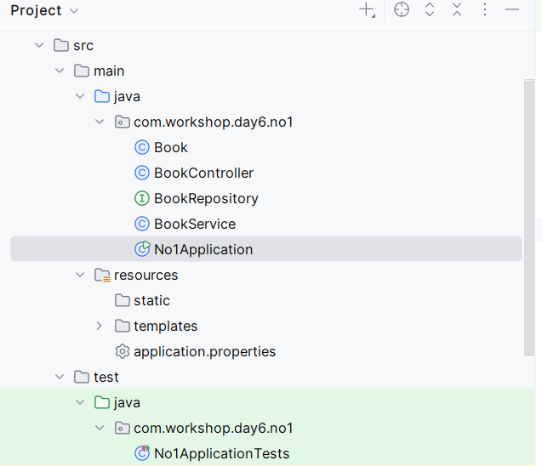

A: Incorrect.
Spring Data JPA requires repositories to extend JpaRepository (or similar interfaces) to automatically provide methods for interacting with the database.

B: Incorrect.
The @Repository annotation is not required in Spring Data JPA repositories because it is auto-applied when extending JpaRepository.
Spring Data JPA automatically marks repository interfaces with @Repository internally.

C: Incorrect.
Without @Entity, Spring won’t recognize the class as a JPA entity, but this would lead to runtime errors rather than the repository not being recognized.

D: Correct.
If the repository is in a different package, it won’t be detected unless explicitly configured.

Q2
Answer is C.

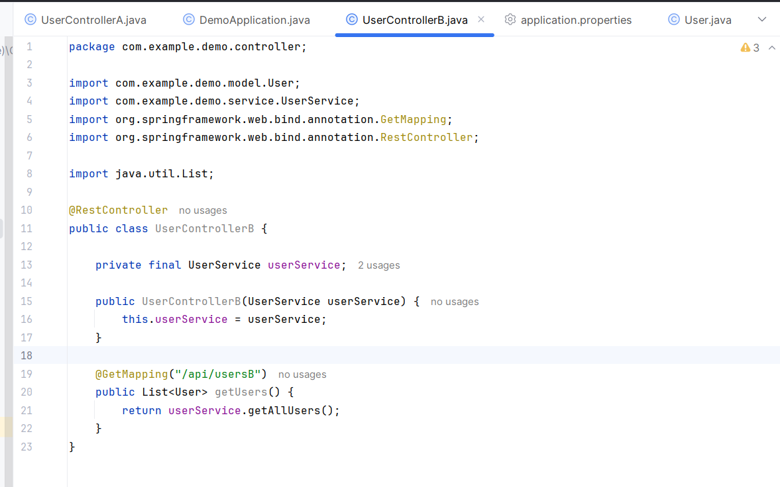

A: Incorrect.
The @Controller annotation marks a class as a Spring MVC controller, but it is used for handling views. It's not suitable for RESTful APIs that return data.

B: Incorrect.
The @Service annotation is used to mark a service class, typically for business logic, and is not used for controllers.

C: Correct.
The @RestController annotation is used to define a controller that handles RESTful API requests and automatically serializes return objects into JSON

D: Incorrect.
The @Repository annotation is used for marking DAO (Data Access Object) classes that interact with the database.

Q3.
Answer is B.

A: Incorrect.
The @Service annotation is necessary because Without it, Spring wouldn't manage this class as a service.

B: Correct.
The findById() method in UserRepository returns an Optional<User>. This approach provides a better handling of null values and avoids unexpected NullPointerException.

C: Incorrect.
While field injection (@Autowired on the field) works, constructor injection is considered a better practice in Spring.

D: Incorrect.
The findById() method does exist in the JpaRepository interface and it returns an Optional<User>.
findById() is a valid method in Spring Data JPA repositories.

Q4.
Answer is B.

A: Incorrect.
The GET method is used to retrieve data from the server. It is not meant for creating new resources.

B: Correct.
The POST method is used to create new resources on the server.

C: Incorrect.
The PUT method is used to update an existing resource or create it if it does not exist.

D: Incorrect.
The DELETE method is used to delete a resource from the server.

Q5.
Answer is C.

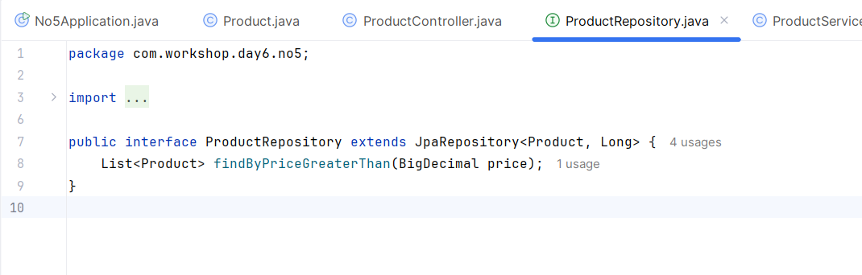

A: Incorrect.
The method findByPriceGreaterThan(BigDecimal price) follows the Spring Data JPA naming conventions and will be correctly interpreted by Spring Data JPA.

B: Incorrect.
Spring Data JPA will automatically generate the implementation for this method, and no runtime exception will occur as long as the method is valid.

C: Correct.
Spring Data JPA automatically generates the implementation for repository methods based on the method signature and the naming convention.

D: Incorrect.
Spring Data JPA automatically generates queries for common methods based on method names. There is no need for a custom implementation here.

Q6.
Answer is A.

A: Correct.
The @Cacheable annotation is used in Spring to cache the result of a method call. When a method annotated with @Cacheable is called, Spring will check the cache for an existing result. If it exists, it returns the cached value instead of executing the method again. This is useful for preventing unnecessary method calls and improving performance.

B: Incorrect.
The @Transactional annotation is used in Spring to define the scope of a transaction. It ensures that a method or a group of methods are executed within a transactional context, meaning the changes made to the database are consistent and can be rolled back if an exception occurs.

C: Incorrect.
The @Async annotation is used to execute a method asynchronously in a separate thread, allowing other method operation to continue without waiting for the method's result. It is useful for methods that take a long time to process and you don’t want to block the current thread.

D: Incorrect.
The @Scheduled annotation is used to schedule tasks to run at fixed intervals. It is typically used for recurring tasks that should be executed at specific times.

Q7.
Answer is B.

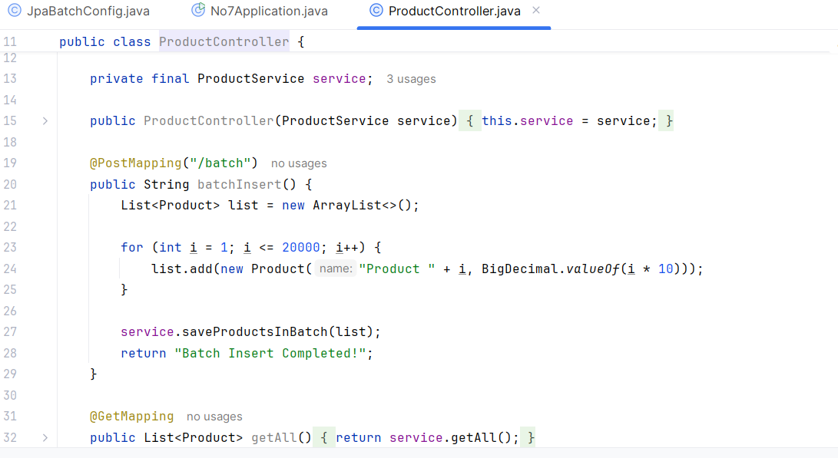

A: Incorrect.
Applying @Transactional to all methods without considering whether they require transactional behavior can lead to performance overhead, particularly for read operations.

B: Correct.
Batch processing allows you to group multiple database operations (like insert, update, or delete) into a single batch request, reducing the number of round trips between your application and the database. This can significantly improve performance for bulk operations because fewer transactions are required, reducing network latency and database load.

C: Incorrect.
Eager fetching loads all related entities immediately with the parent entity. While this might seem efficient, it can result in retrieving unnecessary data, especially when there are large or deep relationships, leading to performance issues like increased memory usage or the "N+1 query problem" (where too many queries are executed for related entities).

D: Incorrect.
Native SQL might be faster in some cases but reduces the benefits of using JPA, such as portability and caching.
Q8.
Answer is B.

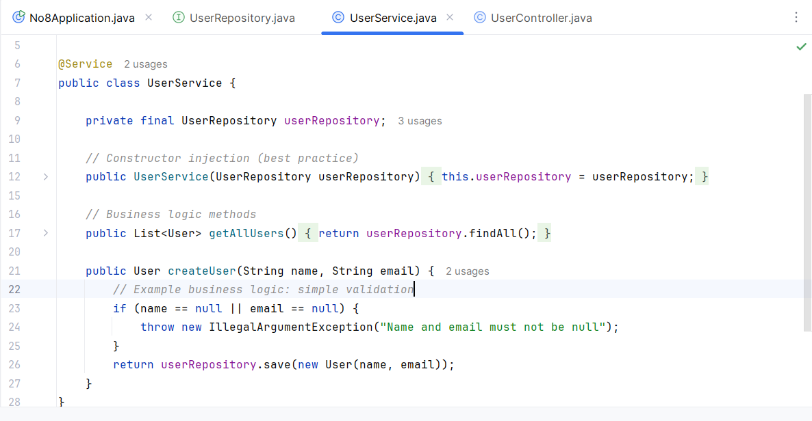

A: Incorrect.
Services should not directly access the database. They should interact with the repository layer, which abstracts the database interactions. This helps in maintaining separation of concerns, making the code more modular, testable, and maintainable.

B: Correct.
In the primary responsibility of the service layer, it should contain business logic — the rules and operations that define how the application behaves. The service layer acts as an intermediary between the repository layer (data access) and the controller layer (handling HTTP requests), ensuring business logic is applied before any data is persisted or returned to the user.

C: Incorrect.
Services in a well-structured Spring Boot application should be stateless. This means they should not maintain user session information or keep state between method calls. Maintaining state in the service layer can lead to scalability and concurrency issues. User session information should be handled at a higher level (e.g., in controllers or through a session management mechanism).

D: Incorrect.
Handling HTTP request and response formatting is the responsibility of the controller layer, not the service layer.
Q9.
Answer is A.

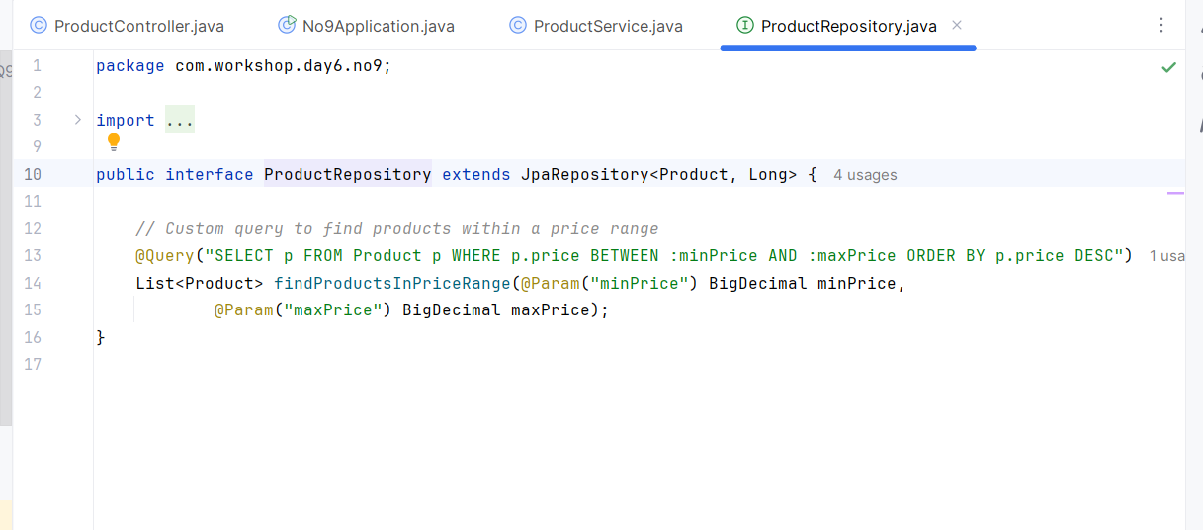

A: Correct.
The @Query annotation can be used in the repository interface to define a custom native SQL query. This method allows you to write complex queries without having to leave the repository layer.

B: Incorrect.
While you could use JDBC in the service layer to execute custom queries, this is not recommended because it violates the separation of concerns. The service layer should be responsible for business logic, while the data access logic should be confined to the repository or DAO layer.

C: Incorrect.
While JPQL(Java Persistence Query Language) is good for most custom queries, it's not always sufficient for all database-specific operations. If the query can't be expressed in JPQL, a native SQL query might be necessary.

D: Incorrect.
Although this approach is valid, it requires you to manually manage the SQL execution and mapping of results to entities, which is less efficient and more verbose compared to using Spring Data JPA's built-in features like @Query in the repository.

Q10.
Answer is A.

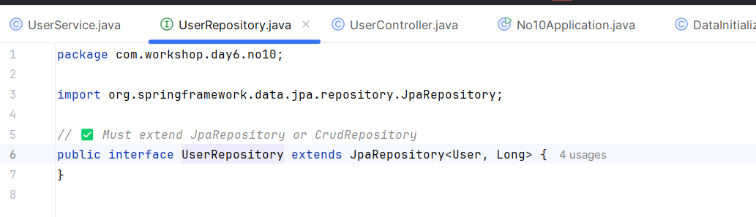

A: Correct.
If the repository interface doesn't extend either of these interfaces, Spring Data JPA won't recognize it as a repository and won't provide the required functionality.

B: Incorrect.
The absence of @Repository is not likely the cause of the issue. Spring Data JPA will still recognize the repository interface, even without the annotation.

C: Also correct.
For Spring Data JPA to recognize a repository, the entity class must be properly annotated with @Entity. If the entity class is missing this annotation, Spring won't be able to map the repository to the entity, causing issues with repository recognition.

D: Also correct.
By default, Spring Boot scans the package of the main application class and all subpackages for components, including repositories. If the repository is in a different package that isn't scanned by Spring Boot, it may not be recognized. However, this can usually be addressed by using @EnableJpaRepositories or @ComponentScan to specify the correct package.

Q11.
Answer is A.

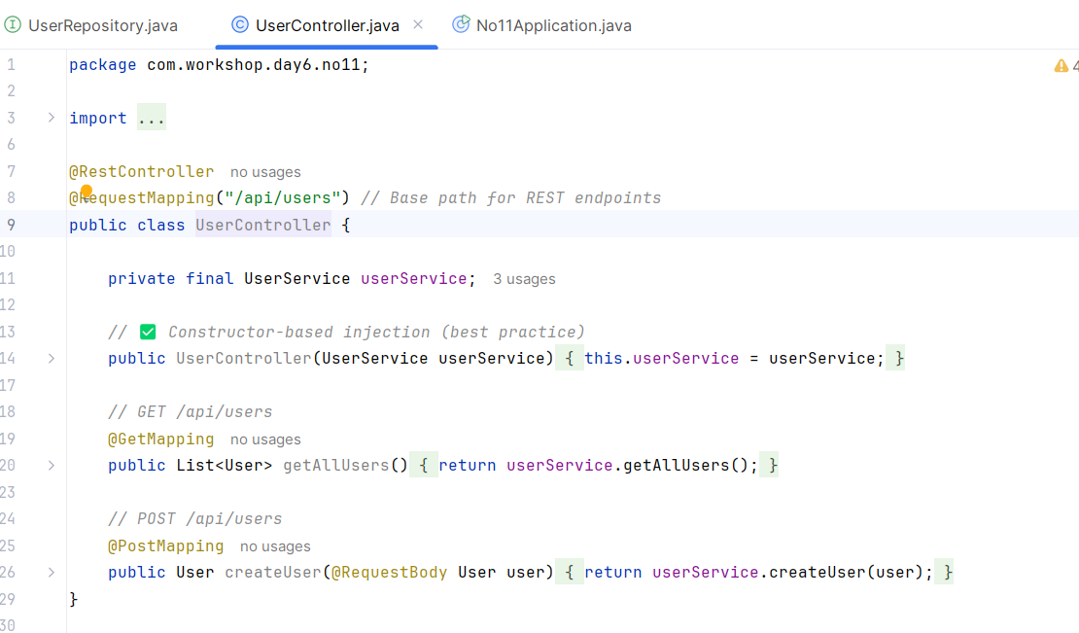

A: Correct.
Without @RestController, Spring will not recognize the class as a controller for handling HTTP requests, so the endpoints will not be accessible. need to add @RestController to UserController class.

B: Incorrect.
@Service, the absence of @Service is not the reason the endpoints are not accessible, because Spring will still inject the UserService even without @Service if the class is picked up by component scanning (for example, by placing it in the correct package).

C: Incorrect.
Using @Autowired on a field is a common and valid approach in Spring for dependency injection. Whether you use field injection (@Autowired) or constructor injection doesn't affect whether the controller endpoints are accessible.

D: Incorrect.
The @GetMapping annotation is correct for defining a GET endpoint in Spring MVC for RESTful APIs.

Q12.
Answer is B.

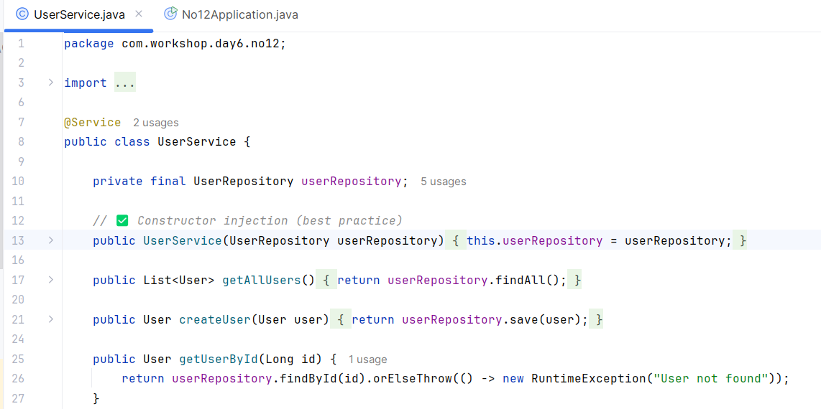

A: Incorrect.
This approach uses field injection, where the @Autowired annotation is applied directly to the field. While this works in Spring Boot, it is generally discouraged because It hides dependencies and makes testing more difficult.

B: Correct.
This is constructor injection, Spring automatically wires the dependencies by calling the constructor and passing the required bean(s).

C: Incorrect.
This approach manually instantiates the UserRepository class using new UserRepository(), which bypasses Spring's dependency injection.

D: Incorrect.
In this case, the BeanFactory.getBean() method is being used to obtain the UserRepository bean manually. it introduces unnecessary complexity and reliance on the Spring context at runtime.

Q13.
Answer is C.

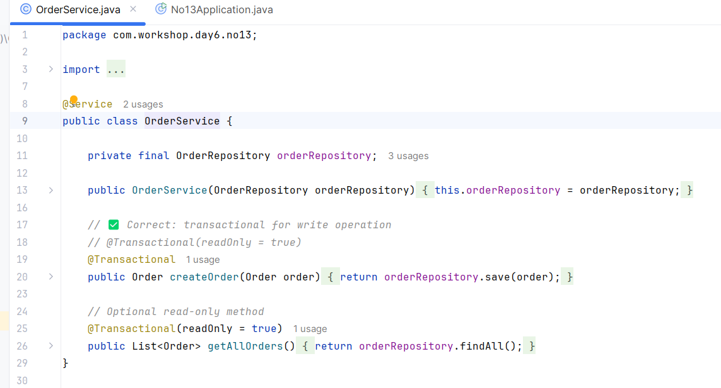

A: Incorrect.
The @Service annotation is perfectly correct for marking a class as a service in Spring. It is commonly used to indicate that the class contains business logic and may be automatically discovered by Spring for dependency injection. This annotation is typically used in service layers, and there’s no issue with it here.

B: Incorrect.
Spring doesn't enforce strict naming conventions for method names. The name createOrder is perfectly fine and follows typical Java naming conventions.

C: Correct.
The @Transactional annotation with readOnly = true is used to mark methods that should only perform read operations (i.e., no modifications to the database). However, createOrder seems to be a method that performs a write operation, such as inserting or updating records in the database.

D: Incorrect.
In this case, if the createOrder method is simply performing an action like creating an order and doesn't need to return anything, returning void is acceptable.
Q14.
Answer is B.

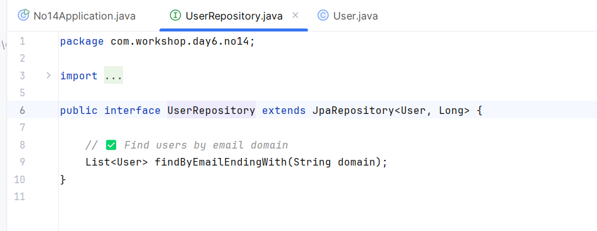

A: Incorrect.
The method name suggests that the query would find users whose email contains the provided domain string. The Containing keyword in Spring Data JPA translates to a LIKE query that checks if the string exists anywhere within the email field.

B: Correct.
The method name suggests that the query will find users whose email ends with the given domain string. The EndingWith keyword is used in Spring Data JPA to generate a query like email LIKE %domain. This would correctly find users whose email ends with the provided domain (e.g., user@domain.com).

C: Incorrect.
the emailDomain is not a standard JPA keyword or convention for derived queries in Spring Data JPA.

D: Incorrect.
because emailDomain isn't a standard property or convention in Spring Data JPA.

Q15.
Answer is A.

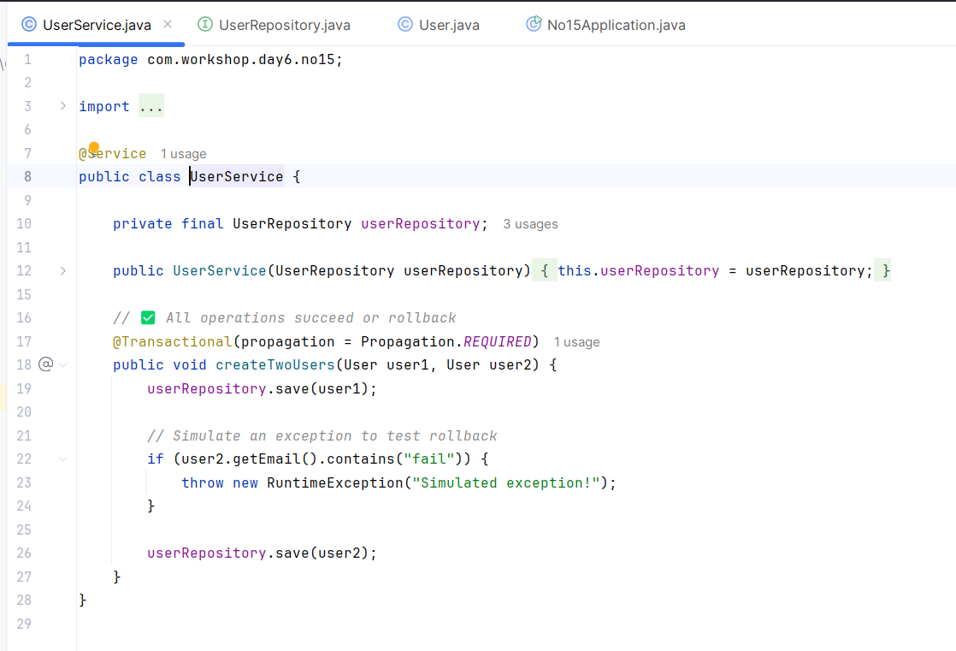

A: Correct.
This annotation ensuring that changes are committed only if all operations succeed because it ensures a single transaction for the method, which will either commit if successful or rollback if an error occurs.

B: Incorrect.
The isolation attribute in @Transactional defines the level of isolation for the transaction. Isolation.SERIALIZABLE is the highest level of isolation and ensures that no other transactions can access the data being processed by the current transaction until it is complete.

C: Incorrect.
The readOnly = false attribute of the @Transactional annotation explicitly marks the transaction as read-write. By default, Spring assumes transactions are read-write, so this setting is redundant unless you specifically want to override a @Transactional(readOnly = true) setting

D: Incorrect.
The noRollbackFor attribute specifies which exceptions should not trigger a rollback. By default, Spring rolls back transactions for unchecked exceptions (e.g., RuntimeException) but not for checked exceptions (e.g., IOException). Using noRollbackFor = Exception.class means that no exception (whether checked or unchecked) will trigger a rollback, and the transaction will always commit regardless of whether an exception occurs.

